3.BOOK

CREATE TABLE book(SNO integer,B_Name varchar(20),Author varchar(20),Price integer,Publisher varchar(20));

INSERT INTO book values(1,'DBMS','Seema Kedhar',250,'Charulatha');

INSERT INTO book values(2,'TOC','John Martin',400,'Tata McGraw Hill');

INSERT INTO book values(3,'C','Balagurusamy',300,'Technical');

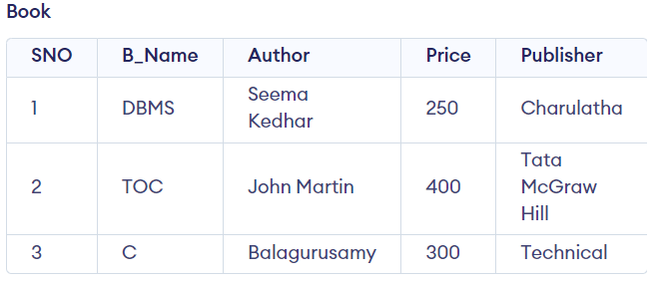

SELECT *

FROM Book;



SELECT B_Name

FROM Book

WHERE Price>=300;

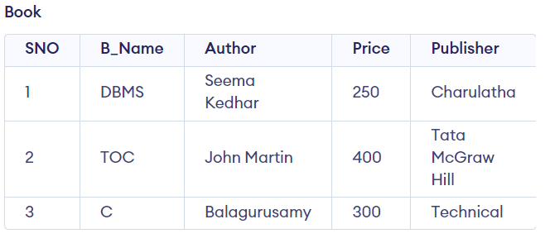

INSERT INTO Book values(4,'Python','Michael',500,'Harish');

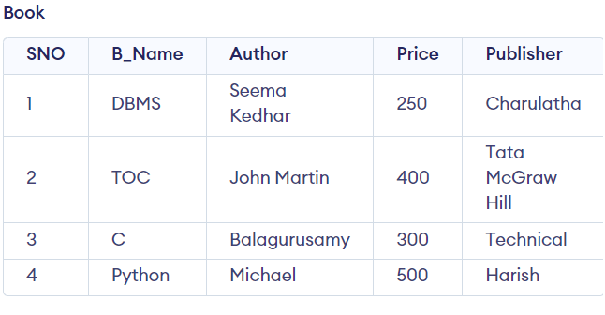

ALTER TABLE Book

DROP COLUMN Author;

